JavaScript Development Environment and Static HTML / CSS Implementation - Week 8

I made a github repo here:  
  
<https://github.com/BryceJLane/Java-Final>  
  
Mimicked the organization we’ve been using for all the other labs.  
  
Made an html and css to give it a similar look to the outline I made:  
  
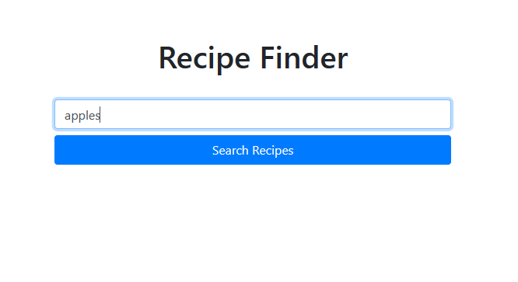

Wanted to keep it simple, will probably add more descriptive info for how to use it and what it does as a summary soon though.